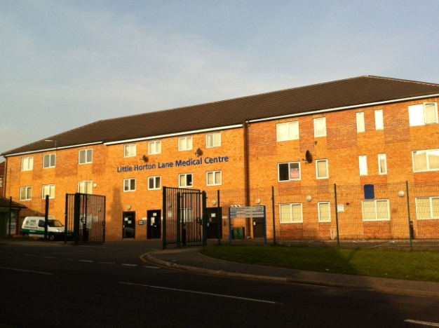
Dr Gilkar & Partners

392 Little Horton Lane
Medical Centre
BD5 0NX
Patient Group
NEWSLETTER: APRIL 2015
This practice is a zero tolerance zone and will not tolerate any kind of verbal or physical abuse.

Our mission statement to you

Dr Gilkar’s Surgery aims to deliver excellent, confidential, accessible healthcare to every patient in a timely, effective manner. Our commitment to personal development enables our staff to become effective members of a caring, friendly, approachable team providing health promotion and prevention services to all patients. As a team we continually work together to achieve high levels of patient satisfaction.

Easter and May Bank Holiday working arrangements for the surgery

FRIDAY 3RD APRIL 2015 ( GOOD FRIDAY) | 09:00 – 18:00
SATURDAY 4TH APRIL (EASTER SATURDAY) | 09:00 – 11:30
MONDAY 6TH APRIL 2015 (EASTER MONDAY) | 09:00 – 18.00
MONDAY 4TH MAY 2015 (BANK HOLIDAY) | CLOSED
MONDAY 31ST AUGUST 2015 ( BANK HOLIDAY) | CLOSED

If you require a doctor when we are closed please dial 111 from
any phone the call is FREE from Landlines and mobiles.
Are you a Carer?
If you look after a family member, friend or neighbour who has a physical disability, mental
health problem, drug/alcohol addiction or who needs extra help due to their age and infirmity,
then you are a carer.
The Carers’ Resource gives tailored support and information to unpaid carers and vulnerable
people. It is an independent, award-winning Yorkshire charity which is open to everyone and
offers free emotional and practical help to enable them to cope.
To find out more about any of our services please don’t hesitate to contact them on
01274 449660
or stop by and visit them at Unit 15, Park View Court, St Pauls Road, Shipley, BD18 3DZ.

Help us to help you…….
Please inform us as soon as possible if you change your address and /or telephone number so that our records can be kept up to date.

